LOCATE NUMBERS
INTRODUCTION:-

Here we are creating database for a peoples telephone directory. The C programming model is going to record the names, addresses, and telephone numbers of people and organizations that the user requires.
First we will define the entities. Look carefully at a page from a telephone directory to identify the entities that it contains like if the user want to access locations of the people from the entered phone numbers The following figure shows a sample page from a telephone directory.

https://help.hcl-software.com/onedb/2.0.0.0/ddi/ids_ddi_166.html
https://help.hcl-software.com/onedb/2.0.0.0/ddi/ids_ddi_166.html

 RESEARCH:-
1. Understanding the Problem Domain:
Telephone directories function like simple databases where a unique key (the phone number) connects to specific details (Name, Address/Location). This project replicates that functionality using C programming.
2. Data Structure Exploration in C:
Different ways to store data were explored:
Arrays: Using separate arrays for names and numbers can be difficult to manage and may lead to errors.
Structures (struct): Structures are identified as the best tool for this task. A structure groups different data types (names and numbers) into a single unit, mimicking a real database record.

 ANALYSIS:-
1. Input/Output Analysis:
Input: The system accepts a 10-digit phone number. This is treated as a string (char array) rather than an integer to handle potential leading zeros or special characters easily.
Output: If the number exists in the database, the system displays the associated Name and Location. Otherwise, it displays a "Not Found" message.
2. Logic Constraints:
The phone number acts as the unique identifier.
Since the data is stored as strings, standard mathematical comparison cannot be used. The program must compare the input with stored numbers character-by-character to ensure an exact match.
3. Feasibility:
For a basic engineering exploration lab, using complex database servers is unnecessary. Storing data directly in the program memory using an Array of Structures is the most feasible solution to demonstrate data retrieval concepts.
 IDEATE:-
1. Proposed Solution:
We designed a solution using an Array of Structures.
Entity: We created a structure called directory with string variables for name, phone, and area.
Data: We will create an array dir[5] and fill it with 5 sample people (like cricketers) to test our code.
2. Algorithm Steps:
Start the program.
Load the sample data into the structure.
Ask the user for a phone number.
Use a loop to check every stored number against the user's input.
If they match -> Print Name and Area, then stop.
If the loop ends with no match -> Print "Number not found."
7.Stop.

It is efficient for our small project and clearly shows how to find a result based on a query.

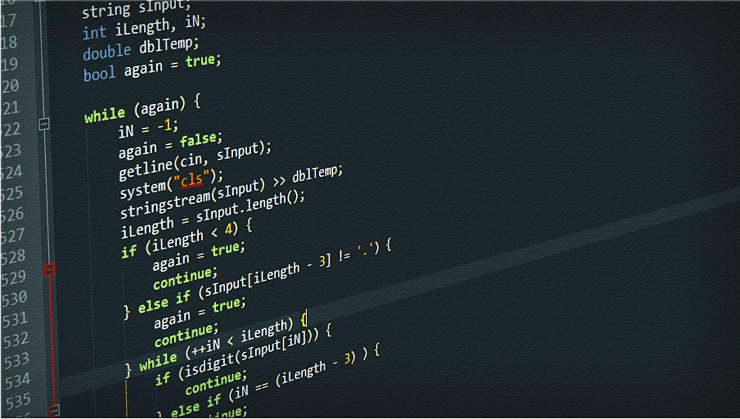 BUILD:-
#include <stdio.h>
struct directory {
char name[30];
char phone[15];
char area[30];
};

int main() {
struct directory dir[5] = {
{"Ravindra_Jadeja", "7465873647", "Pune"},
{"Virat_Kohli", "9404884040", "Pune"},
{"Praneel_Batchmate", "7447473838", "Pune"},
{"Narendra_Modi", "7463529876", "Mumbai"},
{"Rahul_Gandhi", "9783456784", "Nagpur"}
};

char num[15];
int i, j, same, found = 0;

printf("Enter phone number to search: ");
scanf("%s", num);

for (i = 0; i < 5; i++) {
same = 1;
for (j = 0; num[j] != '\0' || dir[i].phone[j] != '\0'; j++) {
if (num[j] != dir[i].phone[j]) {
same = 0;
break;
}
}

if (same == 1) {
printf("Name: %s\n", dir[i].name);
printf("Location/Area: %s\n", dir[i].area);
found = 1;
break;
}
}

if (found == 0) {
printf("Number not found in directory.\n");
}

return 0;
}

 TESTING

Test 1
Enter phone number to search: 1234567895
Number not found in directory.

=== Code Execution Successful ===

Test 2
Enter phone number to search: 7465873647
Name: Ravindra_Jadeja
Location/Area: Pune

=== Code Execution Successful ===

Test 3
Enter phone number to search: 7447473838
Name: Praneel_Batchmate
Location/Area: Pune

=== Code Execution Successful ===

Test 4
Enter phone number to search: 8463547336
Number not found in directory.

=== Code Execution Successful ===

 IMPLEMENTATION

The project is published on Git hub.Which is publicly accessible.

https://github.com/LIKHIT00git/Telephone-DIrectory

